LeanCon Homework Readme

## Overview

The project contains:

* BE (Python)
* FE (React)

The approach is BE oriented, the IFC file path and name is hardcoded in BE (*base_structure.ifc* only).

The file *base_structure.ifc* shall be located at C:/.

FE is fetching the single endpoint <<GET>> /elements to get all elements data and summary.

After receiving JSON, FE shows elements on the scene and summaries at the table, then handles user interactions on the table (highlighting).

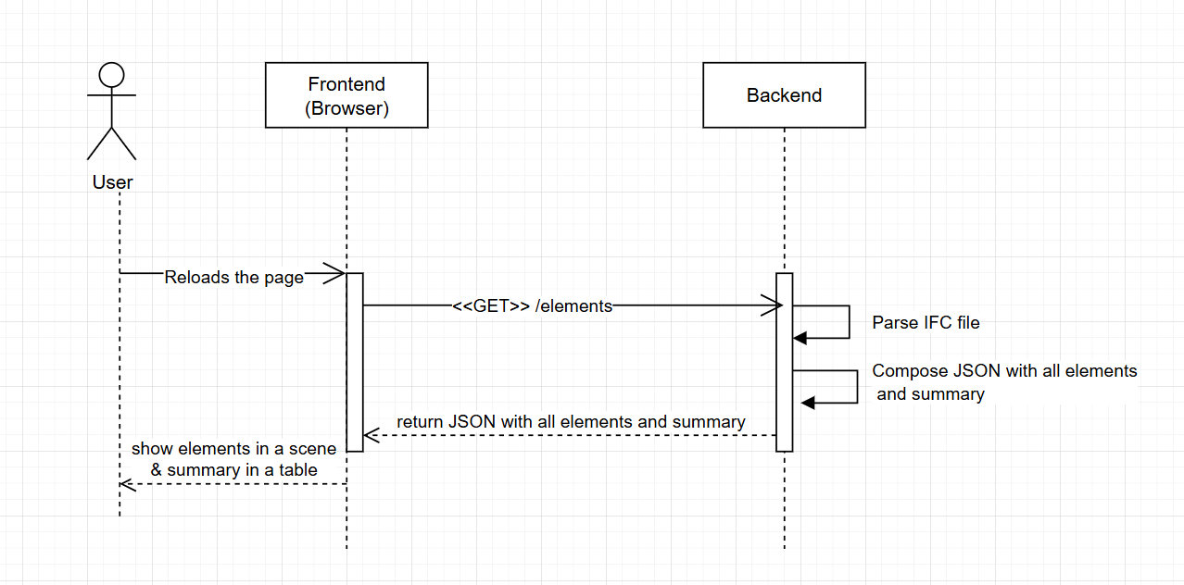

## Git

<https://github.com/JuliaF929/LeanConIFC.git>

## Backend

* Use FastAPI library for REST API implementation
* Shall run on localhost (in order to eliminate CORS errors)
* Parses EFC file to get elements’ types, locations, quantities, levels

## Frontend

* Tried to use ThatOpenCompany (web-ifc & web-ifc-three) to 3D display of the scene, but failed to resolve its version inconsistancies with other components, so using THREE.
* Unfortunately the elements’ locations seam uncorrect, so the elements are disassembled.  
  This is the bug that I did not fix.

## How to run

I have run the whole project on Windows.

Open 2 terminals and a browser and do:

**Terminal#1 (BE):**

*python -m venv venv*

*venv\Scripts\activate*

*pip install -r requirements.txt*

*uvicorn src.main:app --reload --port 8000*

**Terminal#2 (FE dev server):**

*cmd /c "cd /d C:\JuliaF\Julia\CV_2025\2025\LeanCon\ifc-viewer && npm run dev -- --host --port 5173"*

**Browser (FE):**

[*http://localhost:5173*](http://localhost:5173)